1. Semiconductor diodes
   1. Semiconductors
      1. n-type
      2. p-type
   2. p-n Junction diode and their V-I characteristics
   3. Zener diode
   4. Half and full wave rectifier
   5. Voltage regulation using Zener diodes
2. Transistor
   1. Transistor action
   2. Transistor biasing
   3. DC characteristics of CE,CB and CC configurations
   4. Transistor Amplifier and oscillators
      1. CE,CB and CC amplifiers
      2. Current, voltage and power gains
      3. Frequency responses
      4. Feedback
         1. Positive
         2. Negative
      5. Oscillators and masturbators
      6. Multivibrator
         1. Astable
         2. Monostable
   5. Field effect transistors
      1. FET
      2. MPOSFET
      3. Characteristics, biasing and applications
3. Operational amplifier
   1. Difference amplifier
   2. CMRR
   3. Ideal operational amplifier
   4. Inverting amplifier
   5. Non-inverting amplifier
   6. General purpose IC operational amplifier
   7. Integrator, adder, comparator, differentiator, converter
4. Instrumentation
   1. Avometer
   2. Signal generator
   3. oscilloscope

**Semiconductor diodes**

**Semiconductors:** A semiconductor is a material that has intermediate electrical conductivity between a conductor and an insulator, and is used in electronic devices. Energy gap between conduction and valence band is 2-3 eV.

**Conductors:** A conductor is a material that allows electricity to flow through it easily. This is typically due to the presence of free electrons that can move through the material in response to an electric field. Examples of conductors include metals such as copper, aluminum, and gold. Energy gap between conduction and valence band is 0 eV. They overlap.

**Insulators:** An insulator, on the other hand, is a material that does not allow electricity to flow through it easily. This is because the electrons in an insulator are tightly bound to their atoms and are not able to move freely. Examples of insulators include rubber, glass, and plastic. Energy gap between conduction and valence band is more than 3 eV.

**Intrinsic semiconductor:** An intrinsic semiconductor is a pure semiconductor material, which means it is made of only one type of atom, and it has no intentional impurities (also known as dopants) added to it.

**Extrinsic semiconductor:** An extrinsic semiconductor is a semiconductor material that has been intentionally doped with impurities to alter its electrical properties. Extrinsic semiconductors can be either p-type or n-type, depending on the type of impurities added. P-type semiconductors have positively charged holes as the majority carriers, while n-type semiconductors have negatively charged electrons as the majority carriers. Extrinsic semiconductors are used extensively in electronic devices such as diodes, transistors, and integrated circuits.

**Masking:**

**Etching:**

**Wafer:**

**Chip:**

**Doping:**  Doping is the intentional introduction of impurities into a semiconductor material in order to modify its electrical properties, which is crucial for the production of modern electronic devices.

**Drift:** The process in which charge particles move because of an electric field is called drift.

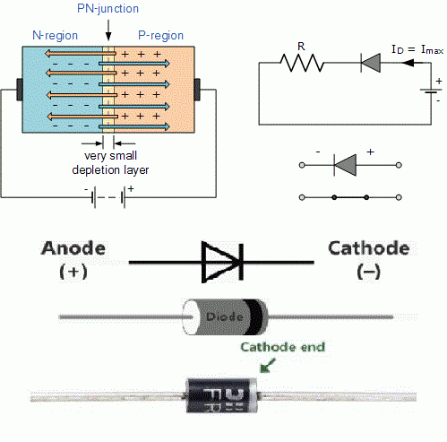**P-n Junction diode:** A p-n junction diode is a semiconductor device made by combining a p-type semiconductor with an n-type semiconductor. It controls the flow of current by allowing it to pass easily in one direction (forward bias) but reducing it greatly in the opposite direction (reverse bias). P-n junction diodes are used in electronic circuits for tasks such as voltage regulation, signal rectification, and switching.

**Forward bias:** Forward bias is a condition in a diode where the anode is connected to a positive voltage source and the cathode is connected to a negative voltage source or ground, which allows current to flow through the diode. In forward bias, the diode conducts current easily with a low voltage drop, and it is used in many electronic circuits, such as rectifiers, voltage regulators, and signal detectors

**Reverse bias:** Reverse bias is a condition in a diode where the diode's anode is connected to a negative voltage source and the cathode is connected to a positive voltage source or ground. In this condition, the diode blocks the flow of current, except for a very small leakage current. Reverse bias is used in electronic circuits such as voltage protection circuits, oscillators, and wave shaping circuits.  
**V-I characteristics:**

1. 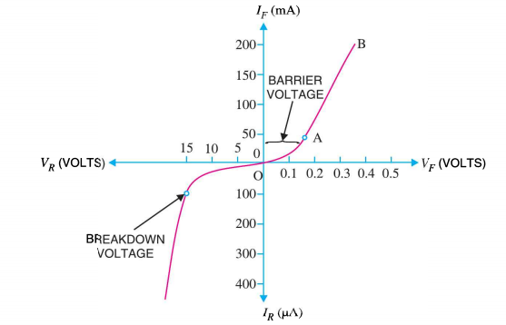**Forward:** Forward bias reduces potential barrier. At a certain voltage, current starts flowing. Current increases with voltage. At first, current increases slowly and curve is non-linear (region OA). Once voltage exceeds barrier voltage, curve rises sharply and becomes almost linear (curve AB).

1. **Reverse:** Reverse bias increases potential barrier. Junction resistance becomes very high and no current flows (except for small reverse saturation current due to minority carriers). Further increase in reverse voltage can lead to breakdown of the junction, characterized by sudden increase in reverse current and fall in resistance.

**Leakage current:** Current due to minority charge career.

**Avalanche breakdown:** A type of breakdown that can occur in a reverse-biased diode when the electric field across the depletion region is strong enough to cause a chain reaction of electron-hole pair generation due to collision ionization. This results in a sudden surge of current flow through the diode.

**Zener breakdown:** A type of breakdown that can occur in a reverse-biased diode when the electric field across the depletion region is strong enough to cause the covalent bonds in the crystal lattice to break, creating a large number of electron-hole pairs. This results in a sudden surge of current flow through the diode. Zener breakdown occurs at a specific voltage, called the Zener voltage, which is determined by the doping level of the diode. Zener breakdown is used in Zener diodes, which are designed to operate in the breakdown region and are commonly used in voltage reference circuits, voltage regulators, and surge protectors.

**Depletion layer:** The depletion layer in a diode is a region near the junction of the P-type and N-type materials where there are no mobile charge carriers. The depletion layer is created by the diffusion of majority charge carriers across the junction when the P-type and N-type materials are brought into contact. The presence of the depletion layer creates a barrier to the flow of current through the diode when it is reverse-biased, and it is an essential component in the operation of a diode.

**Zener diode:** A Zener diode is a type of diode that is specifically designed to operate in the breakdown region, known as the Zener breakdown region. Zener diodes are heavily doped so that they have a very thin depletion region, which allows them to conduct current in the reverse bias direction when a certain voltage, called the Zener voltage, is reached.

**Zener equivalent circuits:**

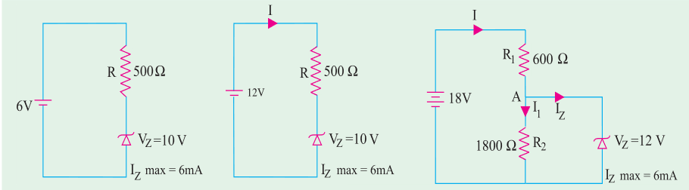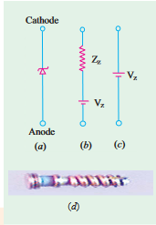

**Utilization of the Zener effect*:*** The Zener effect is a type of electrical breakdown that occurs in a reverse-biased PN junction when the electric field enables tunnelling of electrons from the valence to the conduction band of a semiconductor, leading to a large number of free minority carriers which suddenly increase the reverse current.

**Zener Diode Characteristic:**

* The Zener diode is designed to operate in the reverse-biased breakdown region, known as the Zener breakdown region.
* When a reverse voltage is applied to the Zener diode, a small reverse current called the Zener current flows through the diode until the Zener voltage is reached.
* Once the voltage across the diode reaches the Zener voltage, the Zener diode starts to conduct a much larger reverse current that is almost independent of the voltage across the diode.
* The Zener voltage is a specific voltage that is determined by the doping level and physical characteristics of the Zener diode.
* Zener diodes are commonly used in electronic circuits to provide a stable reference voltage or to protect sensitive components from voltage spikes.
* Zener diodes have a high power handling capacity and are available in various voltage ratings, making them suitable for a wide range of applications.

**Half and full wave rectifier:**

1. **Half wave:**
2. **Full wave:**

**Voltage regulation using Zener diodes:**

To use a Zener diode for voltage regulation, it is typically connected in parallel with the load that needs to be regulated. The Zener diode is reverse biased, which means that the anode is connected to the positive voltage and the cathode is connected to the negative voltage. When the voltage across the Zener diode reaches the Zener voltage, it starts to conduct and maintains a nearly constant voltage across the load.

(Math)

**Transistor**

**Transistor:** A transistor is a semiconductor device used to amplify or switch electrical signals and power.

**Transistor biasing:** To get the desired switching or amplification effect a transistor must be supplied with the control amount of voltage and current through it. This technique is known as transistor biasing. If the transistor is not biased appropriately, that can lead to poor amplification of the signal resulting in the gain being very low. Hence to get the desired outcome, biasing plays a major role.

**4 types of biasing:**

1. Base resistor/ fix bias.
2. Collector to base.
3. Collector-feedback resistors.
4. Voltage divider.

**Transistor action**: refers to the behavior of a transistor in which a small input signal controls a larger output signal. The input signal controls the flow of current through the transistor, which in turn affects the output signal.

**Stabilization:** The process of making the operating point independent to the temperature and various transistor parameters is called stabilization.

**Thermal runaway:** The self-destruction or the burn out of transistor due to the rise of temperature is called thermal runaway.

**Operating point:** The point which is obtained from the Ic and the Vce when there is no input signal is known as operating point.

**DC characteristics of CE, CB and CC configurations (BJT):**

**Amplifier:** An amplifier is an electronic circuit or device that increases the amplitude or power of an electrical signal.

**Oscillator:**

An electric circuit that produces a periodic oscillating electronic signal and convert DC to AC signal

**Condition of oscillation:**

1. The phase shift around the feedback loop must be 0°
2. The voltage gain around the closed feedback loop (loop gain) must be 1. (|AB|=1)

**Damped oscillation:** Oscillations whose amplitude keeps decreasing (or decaying) with time are called **damped** or **decaying** oscillations. (|AB|<1)

**Undamped oscillation:**Oscillations whose amplitude remains constant i.e. does not change with time are called undamped oscillations. (|AB|=1 (Barkhauson principle) and phase shift=0°)

**Hartley oscillator:** The Hartley oscillator is an electric oscillator circuit in which the oscillation frequency is determined by a tuned circuit consisting of capacitors, inductors that are an LC oscillator.

### Advantages:

The advantages of Hartley oscillator are

* Instead of using a large transformer, a single coil can be used as an auto-transformer.
* Frequency can be varied by employing either a variable capacitor or a variable inductor.
* Less number of components is sufficient.
* 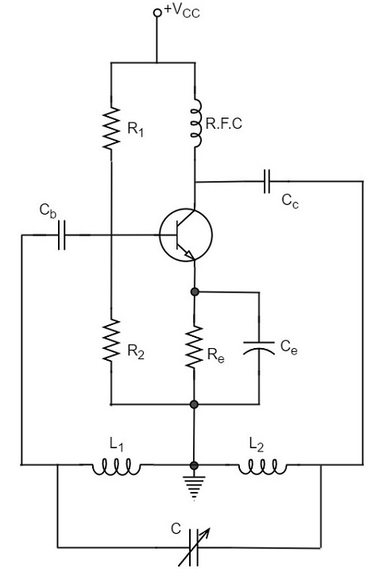The amplitude of the output remains constant over a fixed frequency range.

**Disadvantages:**

The disadvantages of Hartley oscillator are

* It cannot be a low frequency oscillator.
* Harmonic distortions are present.

**Applications:**

The applications of Hartley oscillator are

* It is used to produce a sine wave of desired frequency.
* Mostly used as a local oscillator in radio receivers.
* It is also used as R.F. Oscillator.

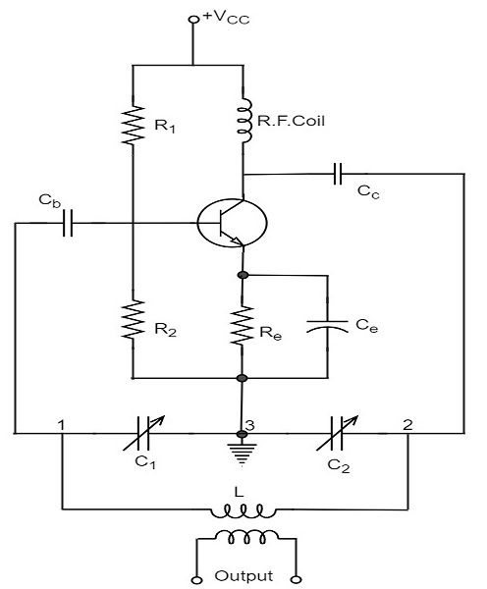**Colpitt’s oscillator:** A Colpitts oscillator looks just like the Hartley oscillator but the inductors and capacitors are replaced with each other in the tank circuit.

### Advantages:

The advantages of Colpitts oscillator are as follows −

* Colpitts oscillator can generate sinusoidal signals of very high frequencies.
* It can withstand high and low temperatures.
* The frequency stability is high.
* Frequency can be varied by using both the variable capacitors.
* Less number of components is sufficient.
* The amplitude of the output remains constant over a fixed frequency range.

**Applications**

The applications of Colpitts oscillator are as follows −

* Colpitts oscillator can be used as High frequency sinewave generator.
* This can be used as a temperature sensor with some associated circuitry.
* Mostly used as a local oscillator in radio receivers.
* It is also used as R.F. Oscillator.
* It is also used in Mobile applications.
* It has got many other commercial applications.

**Hartley vs Colpitt’s Table:**

|  |  |  |
| --- | --- | --- |
| **Parameter** | **Hartley Oscillator** | **Colpitts Oscillator** |
| Frequency Range | High | Medium |
| Stability | Poor | Good |
| Tuning Range | Narrow | Wide |
| Circuit Configuration | Inductance and Capacitance in Series | Inductance and Capacitance in Parallel |
| Output Amplitude | Low | High |
| Phase Shift | 180° | 0° |
| Advantages | Simple circuit design, high frequency stability | Good frequency stability, wide tuning range |
| Disadvantages | Poor frequency stability, low output amplitude | Complex circuit design, low frequency stability |
| Additional Parameters | Cost-effective, suitable for RF applications | Suitable for audio and low frequency applications, sensitive to component tolerances |

**Multivibrator:** A multivibrator circuit is an electric circuit that generates square, rectangular, pulse waveform also called as nonlinear oscillator or function generator. It is a two-stage amplifiers with positive feedback. Used in relaxation oscillator, timers, latches and flip-flops.

Uses of Multivibrators

Some of their uses are :

**1.** as frequency dividers,

**2.** as sawtooth generators,

**3.** as square wave and pulse generators,

**4.** as a standard frequency source when synchronized by an external crystal oscillator,

**5.** for many specialised uses in radar and TV circuits,

**6.** as memory elements in computers.

**Duty cycle:** the ratio of ON time and full cycle time. (Calculated in percentages)

**Astable multivibrator:** Astable multivibrators are free running relaxation oscillators which oscillate between two square wave output wave forms.

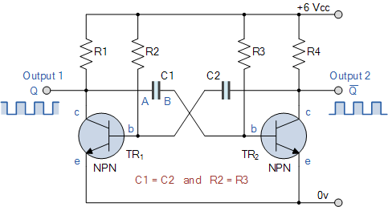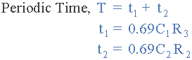

astable multivibrator equation

**Working procedure of astable multivibrator:**

1. Initially, both capacitors in the circuit are charged to the supply voltage level, and both transistors are in the off state.
2. A small amount of noise or disturbance in the circuit causes one of the transistors to turn on. Let's assume transistor TR1 turns on first.
3. When TR1 turns on, the voltage at its collector drops to a low level, and this low voltage is coupled to the base of transistor TR2 through the coupling capacitor. This voltage turns on TR2, causing the output voltage to switch to its high level.
4. The high output voltage from TR2 is then coupled to the base of transistor TR1 through the other coupling capacitor, turning it off.
5. As a result, the voltage at the collector of TR1 begins to rise, and the voltage at the collector of TR2 begins to fall.
6. Eventually, the voltage at the collector of TR1 raises high enough to turn it off, while the voltage at the collector of TR2 falls low enough to turn it off.
7. At this point, the circuit has completed one cycle of oscillation, and the process repeats itself, with TR1 turning on and TR2 turning off.
8. The frequency of oscillation is determined by the time constant of the resistors and capacitors in the circuit.

**Monostable multivibrator:**  A multivibrator that has two distinct states, one of them is stable and the other one is unstable.

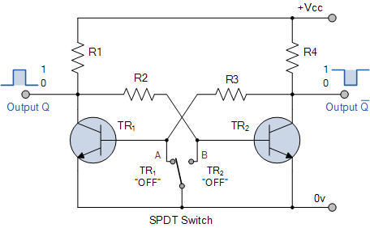

**Bistable multivibrator:** When a multivibrator has two stable state then it is called bistable multivibrator.



**Amplifier vs Oscillation vs Multivibrator table:**

**FET (**Characteristics, biasing and applications**):**

**MPOSFET (**Characteristics, biasing and applications**):**

**Table of FET, BJT, MPOSFET:**

**Operational amplifier**

**Op-Amp:** An active circuit designed to perform mathematical operation of addition, subtraction, multiplication, division, differentiation and integration.

**Slew rate:** The amount of time it takes for the op-amp to step to another voltage level. (Rate of change of the voltage per unit time). (V/micro second)

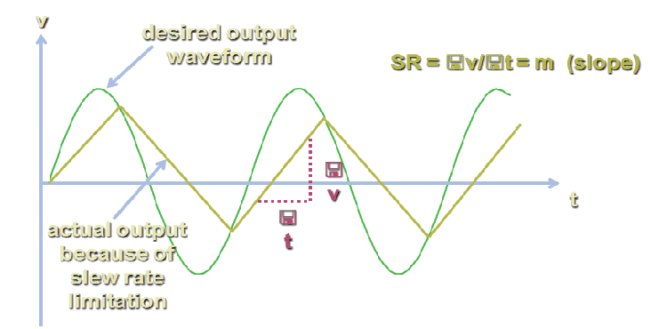

**Common mode rejection ratio:** Ability of an op-amp to reject input signal applied to both inputs simultaneously.

**Input offset voltage:** it’s a parameter defining the differential DC voltage required between the inputs of an amplifier to make the output voltage zero when the differential input is zero.

**Ideal operational amplifier:** An ideal operational amplifier (op-amp) is a theoretical device that has infinite open-loop gain, infinite input impedance, zero output impedance, infinite bandwidth, and zero offset voltage. In practical terms, this means that an ideal op-amp would have the following characteristics:

1. Infinite open-loop gain: The op-amp would amplify the input signal by an infinite amount, regardless of the input voltage. **A**v= - $∞$
2. Infinite input impedance: The op-amp would have no effect on the input signal, as it would draw no current from the input source. **R**i= - $∞$
3. Zero output impedance: The op-amp would be able to supply any amount of current to the load, without any voltage drop across the output terminals. *R*0 = 0 Ω
4. Infinite bandwidth: The op-amp would be able to amplify signals at any frequency, without any distortion or loss of signal.
5. Zero offset voltage: The op-amp would have no voltage difference between its input terminals when the input signal is zero, which means that it would not introduce any errors into the output signal.

**Inverting amplifier:** An inverting operational amplifier (op-amp) is a type of amplifier circuit that amplifies an input signal while inverting its polarity. The input signal is applied to the inverting input terminal of the op-amp, and the output signal is taken from the output terminal.

The basic circuit diagram of an inverting op-amp is shown below:

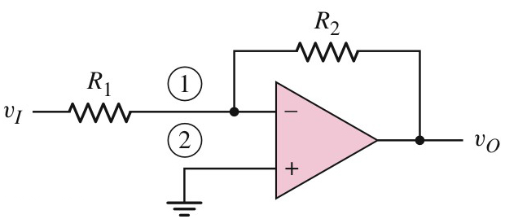 

Voltage at node 1 (inverting) = voltage at node 2 (non-inverting) KCL at node 1:

(Vi – 0) / R1 = (0– VO) / R2

Vi / R1 = - Vo / R2

Since the gain is negative, the output signal is inverted with respect to the input signal. The value of the feedback resistor RF can be adjusted to control the gain of the amplifier. The input resistor Rin and the feedback resistor Rf also set the input impedance and the output impedance of the amplifier.

Inverting op-amps are commonly used in signal amplification, filtering, and signal conditioning applications.

**Non-inverting amplifier:** A non-inverting operational amplifier (op-amp) is a type of amplifier circuit that amplifies an input signal while maintaining the same polarity. The input signal is applied to the non-inverting input terminal of the op-amp, and the output signal is taken from the output terminal.

The basic circuit diagram of a non-inverting op-amp is shown below:

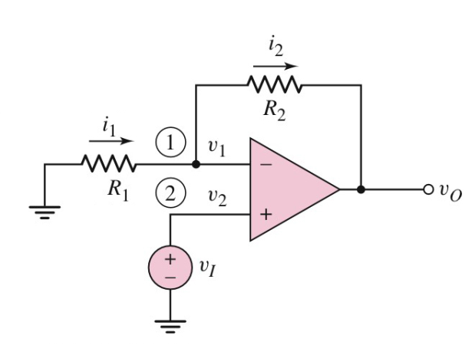 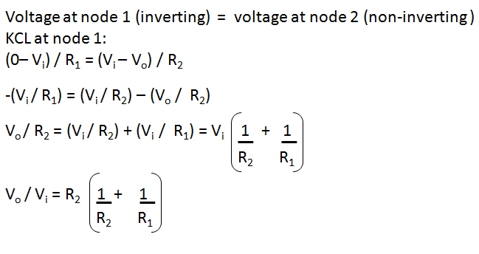

Since the gain is greater than one, the output signal is amplified with respect to the input signal. The value of the feedback resistor R2 can be adjusted to control the gain of the amplifier. The input resistor R1 and the feedback resistor R2 also set the input impedance and the output impedance of the amplifier.

Non-inverting op-amps are commonly used in signal amplification, filtering, and signal conditioning applications where maintaining the same polarity is important.

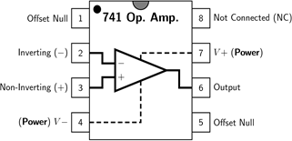**General purpose IC operational amplifier:** A general-purpose IC operational amplifier (op-amp) is a type of electronic component that is designed to perform a variety of analog signal processing functions. It is a versatile device that can be used in a wide range of applications, including amplification, filtering, signal conditioning, and many more.

The most commonly used general-purpose IC op-amp is the 741 op-amp. This op-amp has eight pins, and is designed to be powered by a single power supply voltage, typically between 5V and 18V. The basic pin out diagram of a 741 op-amp is shown below:

**Maximum Ratings**

Supply Voltage ±18 V

Power Dissipation 500 mW

Diff. Input Voltage ±30 V

Input Voltage ±15 V

Operating Temperature 0°C to 70°C

**Characteristics**

Input Offset Voltage 2 to 6 mV

Input Resistance .3 to 2 MΩ

CMMR 70 to 90 dB

Bandwidth .5 to 1.5 MHz

Slew Rate .5 V/µs

**Integrator:**

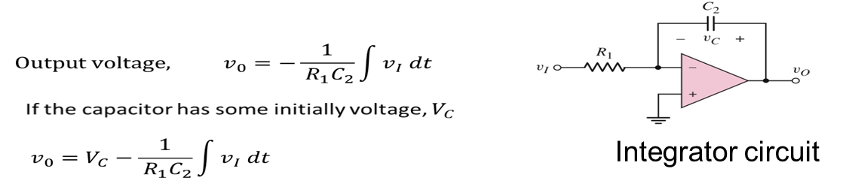

**Adder:**

 

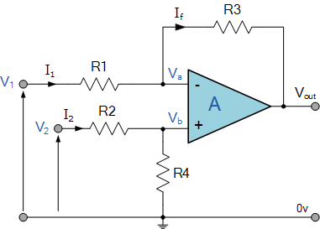**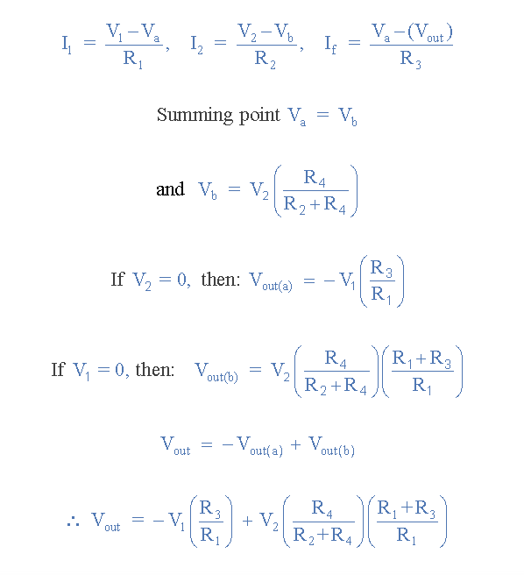Comparator:**

**Differentiator:**

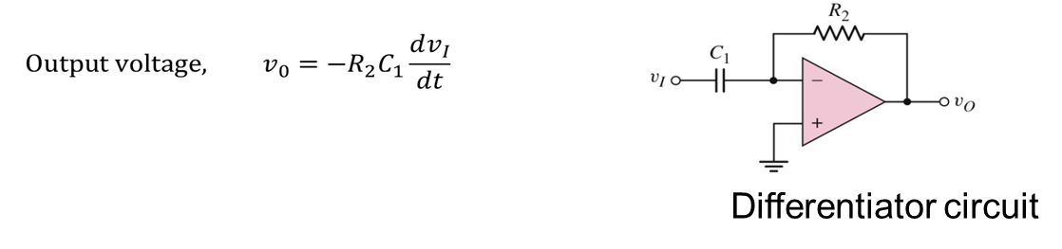

**Instrumentation**

**Avometer:** An Avometer, also known as a multimeter, is a measuring instrument used to measure different electrical quantities, such as voltage, current, and resistance. It typically has a digital or analog display and various settings for different measurement types. It is a versatile tool used by electricians, technicians, and hobbyists for troubleshooting and testing electrical circuits.

**Signal generator:** A signal generator is an electronic device that produces various types of electrical waveforms, such as sine, square, and triangle waves, at different frequencies and amplitudes. It is commonly used in electronics testing and design, where a signal with a known frequency and amplitude is needed for testing and calibration. Signal generators can be either analog or digital and are available in various types and models.

**Oscilloscope:** An oscilloscope, also known as a scope, is a measuring instrument used to display and analyze the waveform of an electrical signal over time. It displays the signal as a graph on a screen, where the vertical axis represents voltage, and the horizontal axis represents time. It is commonly used by engineers and technicians to troubleshoot and analyze electronic circuits, such as audio circuits, power supplies, and microcontroller systems. Modern oscilloscopes may also have advanced features such as digital signal processing, waveform analysis, and automated testing.